E-REGIO project will analyse, test and validate a new way to implement Local Energy Markets around energy storage units and flexible assets supervised by the Local System Operator (LSO). The real Local Energy Markets, enabling actors to exchange local and renewable electricity in a neighbourhood, will be implemented in Norway and Sweden to demonstrate the feasibility and business potential of the concept.

Deliverable nº:
Deliverable name: FAT – E-Regio
Version: 1.0
Release date: 06/09/2019
Dissemination level: Public (Public, Confidential)
Status: Approved (Draft, Peer-reviewed, Submitted, Approved)
Author: eSmart Systems – Susann K. Eriksen, Jon Egil Spetaas

Document history:
Version | Date of issue | Content and changes | Edited by
0.1 | 20/08/2019 | First draft version | Frida Josefin Sund
0.2 | 22/08/19 | Updated | Susann Kjellin Eriksen
1.0 | 06/09/19 | Completed | Jon Spetaas

Peer reviewed by:
Partner | Reviewer

Deliverable beneficiaries:
WP / Task
WP3 Digital innovation for local markets

Table of contents
Executive summary 6
1 Introduction 7
2 Test sites 8
3 Master data and Configurations 9
3.1 Asset, area and zone management – Automatic 9
3.1.1 Purpose 9
3.1.2 Assumptions and Pre-Conditions 9
3.1.3 Test Steps: New Asset, area and zone 9
4 Contract Management 13
4.1 Counterparty 13
4.1.1 Purpose 13
4.1.2 Assumptions and Pre-Conditions 13
4.1.3 Test Steps: New Counterparty 13
4.2 Contract Product 14
4.2.1 Purpose 14
4.2.2 Assumptions and Pre-Conditions 15
4.2.3 Test Steps: Prosumer Contract Product 15
4.3 Contract 22
4.3.1 Purpose 22
4.3.2 Assumptions and Pre-Conditions 23
4.3.3 Test Steps: Prosumer Contract 23
5 Events and external information 26
5.1 Verify that weather observations and forecasts have been imported 26
5.1.1 Purpose 26
5.1.2 Assumptions and Pre-Conditions 26
5.1.3 Test Steps 26
5.2 Verify that day ahead prices have been imported 28
5.2.1 Purpose 28
5.2.2 Assumptions and Pre-Conditions 28
5.2.3 Test Steps 28
6 Meter values management and prediction 30
6.1 Receive Main Meter values 30
6.1.1 Purpose 30
6.1.2 Assumptions and Pre-Conditions 30
6.1.3 Test Steps 30
6.2 Receive PV Meter Readings 33
6.2.1 Purpose 33
6.2.2 Assumptions and Pre-Conditions 33
6.2.3 Test Steps 33
6.3 Receive Battery Meter Readings 36
6.3.1 Purpose 36
6.3.2 Assumptions and Pre-Conditions 36
6.3.3 Test Steps 36
6.4 Site Aggregations 38
6.4.1 Purpose 38
6.4.2 Assumptions and Pre-Conditions 38
6.4.3 Test Steps 39
7 Flexibility Management Optimization 41
7.1 Calculate optimal flexibility schedule 41
7.1.1 Purpose 41
7.1.2 Assumptions and Pre-Conditions 41
7.1.3 Test Steps 41
8 Control signals management 43
8.1 Send optimal flexibility schedules to the pilot system 43
8.1.1 Purpose 43
8.1.2 Assumptions and Pre-Conditions 43
8.1.3 Test Steps 43
9 Appendix 1 – Overview of the main processes 45
10 Appendix 2 – User Interfaces 46

Executive summary
The Integrated eSmart platform is a central delivery in the E-Regio project. The platform will be used by the Flexibility Operator to manage flexibility from flexibility providers and offer this to flexibility customers.
This document describes how the Factory Acceptance Test (FAT) of the Integrated eSmart platform version 1 is conducted and the results from the test. The test is run to demonstrate and verify the functionality of the platform and is based on data received from Skagerak Energi. This FAT is run from eSmart’s office in Halden, Norway.
Stig Simonsen (Skagerak Energi), Anders Oftebro Bjørnøy (Skagerak Energi), Xiaomei Cheng (Smart Innovation), Jon Spetaas (eSmart Systems), Susann Kjellin Eriksen (eSmart Systems) and Frida Josefin Sund (eSmart Systems) were present.

Introduction
This document describes how the Factory Acceptance Test (FAT) for the Integrated eSmart system version 1 is conducted. The test is run to demonstrate and verify the platform functionality.
The test cases presented in this delivery are describing the required test steps, including expected results when appropriate. The test cases also define purpose, assumptions and pre-conditions that must be met before the test cases can be run.

Test sites
The FAT is focused on E-Regio test site. The site has been configured into the system ahead of the FAT. The asset hierarchy can be seen in Figure 1.
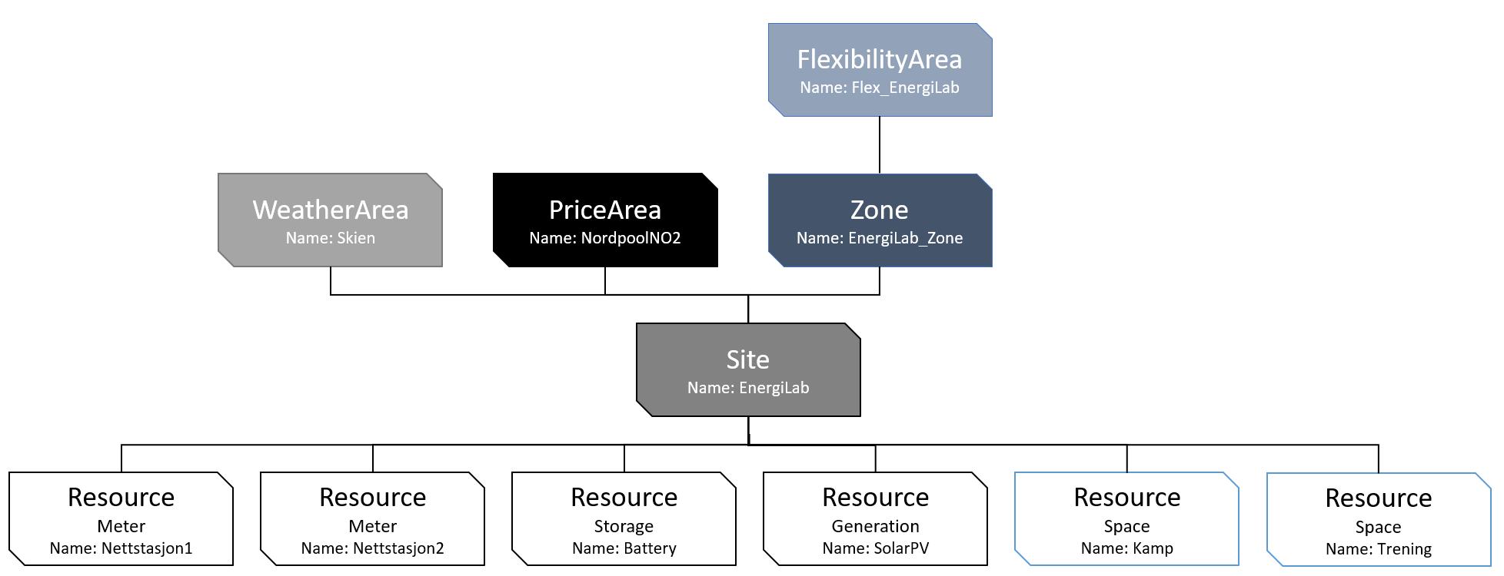
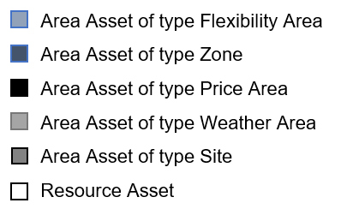

Figure 1: Asset hierarchy

Master data and Configurations
This section describes the test cases related to the master data and configurations process.

Asset, area and zone management – Automatic

Purpose
The purpose of this prosses is to import asset data and hierarchy through the API.
Note! For this FAT test eSmart has already imported the Asset structure. Therefore, the test should start in step 11.

Assumptions and Pre-Conditions
The input-data that are going to be input must be ready at a pre-defined format.

Test Steps: New Asset, area and zone
 | Action | Expected result | Result
 | Configure the asset rest API from the pilot system and send it through the API  URL for Asset:  https://flexplatformapi.esmartapi.com/ | Configuration and sending is successful | NA
 | Assets are sent through the API  Go to point 11. | Assets are imported into the system. | OK
 | Import of assets through Asset Loader document:
 | Open the document: Asset loader | Excel document opens with pre-configured dummy asset | Done prior to FAT
 | Open Swagger: https://flexplatformapi.esmartapi.com/swagger/ui/index | Swagger is opened | NA
 | Click on AssetAPI |  | NA
 | Click on /api/External/AssetAPi/UploadAssetCsvData | UploadAssetsCSV  Data is open | NA
 | Go to Asset loader – FAT.txt and copy all the text |  | OK
 | Go to UploadAssetsCSVData and paste the parameter string into assetCsvdata field. | Parameter string is pasted correctly | NA
 | Click on button “Try it out!” | The dummy assets will be imported into the system | NA
 | Open the Asset Screen | Asset Screen is opened | Parent and Child not displayed in the Connectors tab for the FlexArea and Zone
 | Click on Search and enter an asset name  Click enter or Refresh | All assets with the search “name” are opened in the grid and imported assets are shown in the list. | Ok
 | Double click on an asset and the detail screen is open | Asset detail screen is successfully open | OK
 | Check that the properties and connectors are the same as it is in the pilot systems. | Properties and connectors match the pilot system. | Updated the Installed Min Capacity of the Battery to 220 (20% of 1100)

Contract Management
This section describes the test cases related to the contract management process.

Counterparty

Purpose
The purpose of this process is to enter a Counterparty.

Assumptions and Pre-Conditions
Relevant input data must be ready at pre-defined format.

Test Steps: New Counterparty
 | Action | Expected result | Result
 | Open Counterparty screen | Counterparty screen is opened | OK
 | Click on “+” icon to add new Counterparty | List of fields appears on the right-hand side of the window. | OK
 | Fill in all the required fields:  Name:  Roles: Flexibility Operator, owner and counterparty  Entity Status: Active  Company (org. no) : | The Save button is enabled. | OK
 | Click on Save button | The recently created counterparty is saved and displayed in the list. | OK
 | Verify that recently entered counterparty is saved by entering the counterparty name in the Name field and click “Refresh” button. | Recently entered counterparty is displayed in the grid. | OK

Contract Product

Purpose
The purpose of this process is to enter a Contract Product.

Assumptions and Pre-Conditions
Relevant information about Contract Product is available.

Test Steps: Prosumer Contract Product
 | Action | Expected result | Result
 | Open the Contract Product Screen | Contract Product Screen is opened | Ok
 | Click on “+” icon to add new Contract Product | “Create Contract Product” window is opened. | OK
 | Fill up all the required fields for Contract Product details:  Name :  Contract type:  Entity Status: Active  Price Unit:  Currency Unit:  Quantity Unit :  VAT Percentage:  Available From Time: | Entered details are shown in required fields, and “Save” button is enabled. | OK  Filled in values:  Currency Unit: NOK  Price Unit: NOK/kWh  VAT Percentage: 0%  Available/Delivery From: 2019-01-01
 | Click on “Save” button | Once the “Save” button is clicked, the screen closes. | OK
 | Search for and open the saved Contract product and verify that Flexibility Rules are filled in with default values. Change the CapacityConstraintAppliesToResourceTypes to AllResourceTypes. | Verify that recently created entity still exist in the list, and that CapacityConstraintAppliesToResourceTypes is AllResourceTypes. | OK
 | Click on “Save” button | Entered items are saved and the screen closes. | OK
 | Open the saved Contract product and enter each Contract Product Element by pressing the + and save to list between creating elements by pressing the V icon:  Energy at spotprice:  Amount Type: VariableConsumptionAndSpotprice  Related ContractType: Energy  Calculation Frequency : Hour  Amount Period: Month  Quantity Limit Tier No:  Quantity Lower Limit Operator:  Quantity Lower Limit :  Price Value :  Price Multiplier  Price MarkUp :  Vat Percentage: 25  Entity Status : Active  Surplus energy at double spotprice:  Amount Type: VariableProductionAndSpotPriceWithMarkUp  Related ContractType: Energy  Calculation Frequency : Hour  Amount Period: Month  Quantity Limit Tier No:  Quantity Lower Limit Operator:  Quantity Lower Limit :  Price Value :  Price Multiplier  Price MarkUp : 2  Vat Percentage: 25  Entity Status : Active  Consumption Fee:  Amount Type: FixedFee  Related ContractType : Energy  Calculation Frequency: Month  Amount Period : Month  Quantity Limit Tier: No  Quantity Lower Limit:  Quantity Lower Limit Operator :  Quantity Upper Limit :  Quantity Upper Limit Operator :  Price Value : 47  Price Multiplier:  Price MarkUp :  Vat Percentage: 25  Entity Status: Active  Demand charge tariff:  Amount Type: MaxConsumptionAndVariablePrice  Related ContractType: Grid  Calculation Frequency : Hour  Amount Period: Month  Quantity Limit Tier No:  Quantity Lower Limit Operator:  Quantity Lower Limit :  Price Value :  Price Multiplier  Price MarkUp :  Vat Percentage: 25  Entity Status : Active  (VariablePrice has to be entered as time series to the Contract)  Subscribed Power of 5 kW:  Amount Type: VariableTieredConsumptionAnd FixedPrice  Related ContractType: Grid  Calculation Frequency : Hour  Amount Period: Month  Quantity Limit Tier No: 1  Quantity Lower Limit Operator:  Quantity Lower Limit :  Quantity Upper Limit Operator: <  Quantity Upper Limit: 5  Price Value :  Price Multiplier  Price MarkUp :  Vat Percentage: 25  Entity Status : Active  Additional line of consumption above limit for Subscribed Power of 5 kW:  Amount Type: VariableTieredConsumptionAnd FixedPrice  Related ContractType: Grid  Calculation Frequency : Hour  Amount Period: Month  Quantity Limit Tier No: 2  Quantity Lower Limit Operator: >=  Quantity Lower Limit : 5  Quantity Upper Limit Operator:  Quantity Upper Limit:  Price Value :  Price Multiplier  Price MarkUp :  Vat Percentage: 25  Entity Status : Active | Each contract product element is updated to the Contract Product Element list. | Entered examples:  VariableConsumptionAndSpotPrice, VariableProductionAndSpotPrice, MaxConsumptionAndVariablePrice and VariableConsumptionAndFixedTax
 | Click the “Save” button in Contract Product screen | Contract Product is saved, and the screen is closed | OK

Contract

Purpose
The purpose of this process is to enter a Contract and all parameters for prosumer optimization.

Assumptions and Pre-Conditions
Relevant information for the flexibility Contract has been negotiated with the prosumer.
The Counterparty has already been created in the system.
Contract Product has already been created in the system.

Test Steps: Prosumer Contract
 | Action | Expected result | Result
 | Open the Contract Screen | Contract Screen is opened
 | Click on “+” icon to add new Contract | “Create Contract” window is opened.
 | Fill up all the required fields including for Contract details:  Name : eSmart  Contract Reference:  Contract Type: ProsumerOptimization  Buy Sell type: Sell  Owning Legal Entity: eSmart  Counterparty: eSmart  Contract Product: eSmart  Delivery From Time : 01/01/2019  Entity Status : Active  Area type : FlexibilityArea  Area Name : eSmart FlexArea  Optimization Level: Site  Master Agreement: N/A  Master Contract : N/A |  | Created Contract: Prosumer optimization contract  Between Owner: Skagerak Kraft and Counterparty: Skagerak Nett  As example
 | Contract Parameters are filled out with default values.  Go through the parameters and verify if it’s ok. | Parameters are found to be ok. | NA
 | Click on “Save” button | New contract is saved and the screen closes. | OK

Events and external information
This section describes the test cases related to the events and external information process.

Verify that weather observations and forecasts have been imported

Purpose
The purpose of this process is to import weather observations to investigate the data.

Assumptions and Pre-Conditions
The weather area and its topology have already been defined in the system.
Note! Weather will be imported from EnergiLab for Skagerak pilot.

Test Steps
 | Action | Expected result | Result
 | Open the Asset Screen | Asset Screen is opened | Ok
 | Click on Search and enter an asset name. Click on Refresh | All Assets matching search criteria are displayed in the grid. | OK
 | Select a Weather asset and click on the Time Series Values  ikon | The Time Series Values screen is opened. | No time series values to WeatherArea imported yet.
 | Choose the period, press the plus on Weather asset, check off the Actual Temperature time series and press refresh. | Values are shown in the graph and the grid. | NA
 | Verify that the data looks logical. | Data is logical | NA
 | Repeat the step 4 and 5 for time series:  - Actual Solar Radiation  - Forecasted Temperature  - Forecasted Solar Radiation |  | NA

Verify that day ahead prices have been imported

Purpose
The purpose of this process is to import day ahead prices and investigate the data.

Assumptions and Pre-Conditions
The Price Area and its topology have already been defined in the system.
Note! Prices will be imported from EnergiLag for Skagerak pilot.

Test Steps
 | Action | Expected result | Result
 | Open the Asset Screen | Asset Screen is opened | OK
 | Click on Search and enter PriceArea. Click on Refresh | All Assets matching search criteria are displayed in the grid. | OK
 | Select the PriceArea and click on the Time Series Values  ikon | The Time Series Values screen is opened | OK
 | Choose the period, press the plus on PriceArea, check off the SpotPrice time series and press refresh. | Values will be shown in the graph and the grid. | OK
 | Verify that the data looks logical. | Data is logical. | Unit to time series is NOK/kWh, but the values looks to be EUR/MWh  Skagerak to decide on currency and unit

Meter values management and prediction
This section describes the test cases related to the meter values management and prediction processes.

Receive Main Meter values

Purpose
The purpose of this process is to import Main Meter meter readings, calculate the delta values and estimate (interpolate) any missing values.

Assumptions and Pre-Conditions
The Main Meter resource and its topology have already been defined in the system.

Test Steps
 | Action | Expected result | Result
 | Import the value through timeseries API https://flexplatformapi.esmartapi.com/swagger/ui/index |  | OK
 | When the values are imported these calculations/Workers will automatically be run:  Delta Calculation – Converting Meter Reading to energy  Estimation Calculation - If Meter Reading is missing, the calculation will interpolate | Energy time series are created:  - Production time series  - Consumption time series | Entered energy values thus, no delta or estimation
 | Open the Asset Screen | Asset Screen is opened. | OK
 | Click on Search and enter the Site asset name. Click on Refresh. | All Assets matching search criteria are displayed in the grid. | OK
 | Select the Site asset and click on the Time Series Values  ikon | The Time Series Values screen is opened. | OK
 | Choose the period, choose to see all the children and press the plus on Main meter asset.  Check off the Production meter reading and Production and press refresh button. | Values are shown in the graph and the grid. | OK
 | Verify that the production data is calculated correctly.  Formula: MeterReading t+1 – MeterReading t = Energy per 15 min | Data is correct. | NA
 | Go to the Time Series Values - Search filter, uncheck the time series and then check off the time series Consumption Meter Reading and Consumption | Values will be displayed in the graph and the grid. | OK
 | Verify that the production data is calculated correctly.  Formula: MeterReading t+1 – MeterReading t = Energy per 15 min | Data is correct. | NA
 | Verify that the estimation (interpolation) is correct where the Meter Reading was missing.  Formula: Interpolate between previous value and last value | Data is correct | NA

Receive PV Meter Readings

Purpose
The purpose of this process is to import PV meter readings, calculate the delta values, estimate (interpolate) any missing values and calculate predictions.

Assumptions and Pre-Conditions
The PV resource and its topology have already been defined in the system.

Test Steps
 | Action | Expected result | Result
 | Import the value through timeseries API https://flexplatformapi.esmartapi.com/swagger/ui/index |  | OK  Some tweaking of Units.  Skagerak to send kWh
 | When the values are imported these calculations/Workers will automatically be run:  Delta Calculation – Converting Meter Reading to energy  Estimation Calculation - If Meter Reading is missing the calculation will interpolate.  Forecast Calculation: Production time series are pushed to Prediction service. Prediction service push back the forecasted time series for production. | Energy and prediction Time Series are created:  - Production time series  - ForecastedProduction time series | OK.  Forecast did not run on the imported values, but has run on previous imports
 | Open the Asset Screen | Asset Screen is opened | OK
 | Click on Search and enter a PV asset name. Click on Refresh | All Assets matching search criteria are displayed in the grid. | OK
 | Select the PV asset click on the Time Series Values  ikon | The Time Series Values screen is opened. | OK
 | Choose the period, press the plus on the PV asset, check off the Production meter reading and Production and press refresh button. | Values are shown in the graph and the grid. | OK
 | Verify that the production data is calculated correctly.  Formula: MeterReading t+1 – MeterReading t = Energy per 15 min | Data is correct. | OK
 | Verify that the estimation (interpolation) is correct where the Meter Reading was missing.  Formula: Interpolate between previous value and last value. | Data is correct | OK  Did not enter any holes in the series.
 | Go to the Time Series Values - Search filter, check off the time series Production and ForecastedProduction and press refresh button.  Verify that the prediction is logical. | Values are shown in the graph and the grid. Predictions are logical. | OK
 | Repeat from step 1-9 if there are more than one PV |  | NA

Receive Battery Meter Readings

Purpose
The purpose of this process is to import Battery state of charge and meter readings for charge and discharge, calculate the delta values and estimate (interpolate) any missing values.

Assumptions and Pre-Conditions
The Battery resources and its topology have already been defined in the system.

Test Steps
 | Action | Expected result | Result
 | Import the value through timeseries API https://flexplatformapi.esmartapi.com/swagger/ui/index
 | When the values are imported these calculations/Workers will automatically be run:  Delta Calculation – Converting Meter Reading to energy  Estimation Calculation - If Meter Reading is missing the calculation will interpolate | Energy and prediction Time Series are created:  - ChargingEnergy time series  - DischargingEnergy time series  - EnergyLevel time series | OK  Looked at discharging and EnergyLevel
 | Open the Asset Screen | Asset Screen is opened | OK
 | Click on Search and enter the Battery asset name. Click on Refresh | All Assets matching search criteria are displayed in the grid. | OK
 | Select the battery asset and click on the Time Series Values  ikon | The Time Series Values screen is opened. | OK
 | Choose the period, press the plus on Battery asset, check off the ChargingEnergy, DischargingEnergy and EnergyLevel and press refresh button. | Values are shown in the graph and the grid. | OK
 | Verify that the estimation (interpolation) is correct where the Meter Readings was missing.  Formula: Interpolate between previous values and last values | Data is correct | OK

Site Aggregations

Purpose
The purpose of this process is for the system to calculate Site aggregations based on new energy values to Main Meter, Production, Load, Charging or Discharging.

Assumptions and Pre-Conditions
The Site and its resources have already been defined in the system.
Energy values to Main Meter, Production, Load, Charging or Discharging have been imported.

Test Steps
 | Action | Expected result | Result
 | When the values are imported these calculations/Workers will automatically be run:  Site Calculations and aggregations:  - MeteredConsumption  - MeteredProduction  - ResidualEnergy  Forecast Calculation: ResidualEnergy time series is pushed to Prediction service. Prediction service push back the forecasted time series for ResidualEnergy | Energy and prediction Time Series will be created:  - MeteredConsumption  - MeteredProduction  - ResidualEnergy  - ForecastedResidualEnergy | No forecast for Residualenergy calculated
 | Open the Asset Screen | Asset Screen is opened | OK
 | Click on Search and type site name. Click on Refresh | All Assets matching search criteria are displayed in the grid. | OK
 | Select the site and click on the Time Series Values  ikon | The Time Series Values screen is opened. | OK
 | Choose the period.  Check off the  - MeteredConsumption  - MeteredProduction  - ResidualEnergy  - ForecastedResidualEnergy  and press refresh button. | Values are shown in the graph and the grid. | OK  No ForecastedResidualEnergy
 | Verify that the values are calculated correctly. | Data is correct. | OK

Flexibility Management Optimization
This section describes the test cases related to the flexibility management optimization process.

Calculate optimal flexibility schedule

Purpose
The purpose of this process is to generate an optimal flexibility schedule, in the form of regulation series to devices at Site.

Assumptions and Pre-Conditions
Historical Resource energy values and historical Events and external information exist.
Predicted energy values and charge point status exist.
Flexibility contract, contract product and contract asset parameters exist.
All relevant asset parameters are configured.

Test Steps
 | Action | Expected result | Result
 | Optimization will trigger 5 min after the 15 min values has been imported. Results depend on Controllable type and if OptimalCapacityRegulation should be created. | For Battery and production these time series will be saved as result from optimization:  - ChargingPowerRegulation (Battery)  - DischargingPower  Regulation (Battery) | No optimization able to run yet. Should be tested when all data is flowing.
 | Open the Asset Screen | Asset Screen is opened
 | Click on Search and enter asset name. Click on Refresh | All Assets matching search criteria Pilot are displayed in the grid.
 | Select the site and click on the Time Series Values  ikon | The Time Series Values screen is opened.
 | Investigate and discuss Optimization result time series | Values are shown in the graph and the grid.

Control signals management
This section describes the test cases related to the Control signals management process.

Send optimal flexibility schedules to the pilot system

Purpose
The purpose of this process is to send the optimal flexibility schedule to the pilot system.

Assumptions and Pre-Conditions
Optimal flexibility schedule exists.
Flexibility resources and areas have end points defined in the system.

Test Steps
 | Action | Expected result | Result
 | Optimization has been executed | Optimal flexibility schedule has been saved to time series | No optimization able to run yet. Should be tested when all data is flowing.
 | Power regulation schedule is sent to the relevant pilot system | Power regulation schedule is received by the pilot system

Factory Acceptance Test Results

Sign off
The test criteria have been met or not (Yes/No):  Yes | Date and signature:
Bugs to be fixed by eSmart Systems:  - Parent and Child not displayed in the Connectors tab for the FlexArea and Zone. Will be fixed in the next release | Date and signature:
Bugs to be fixed by Skagerak Energi:  - No time series values to WeatherArea are imported yet. Skagerak to start sending weather values  - Unit to time series is NOK/kWh, but the values looks to be EUR/MWh. Skagerak to decide on currency and unit  - Some tweaking of Units. Skagerak to send kWh | Date and signature:

Customer:
Date: ………………………………...

Name………………………………………………………………………………………….
(Responsible to attest the test protocol)

Company………………………………………………………………………………………….

eSmart:
Date: ………………………………...

Name………………………………………………………………………………………….
(Responsible to attest the test protocol)

Company…………………………………………………………………………………………

Appendix 1 – Overview of the main processes
The main processes in the IIP is shown below. The processes and the links between them constitutes the functionality of the platform.

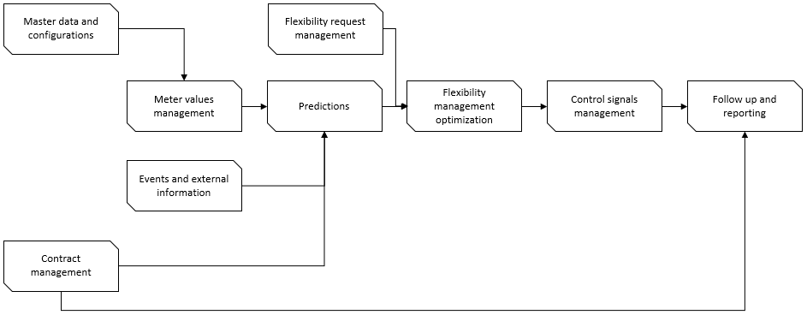
Figure 2: Overview of the Integrated platform main processes

Appendix 2 – User Interfaces
Pictures of relevant user interfaces in the IIP are presented below. The user interfaces are used in the test cases presented in this deliverable.
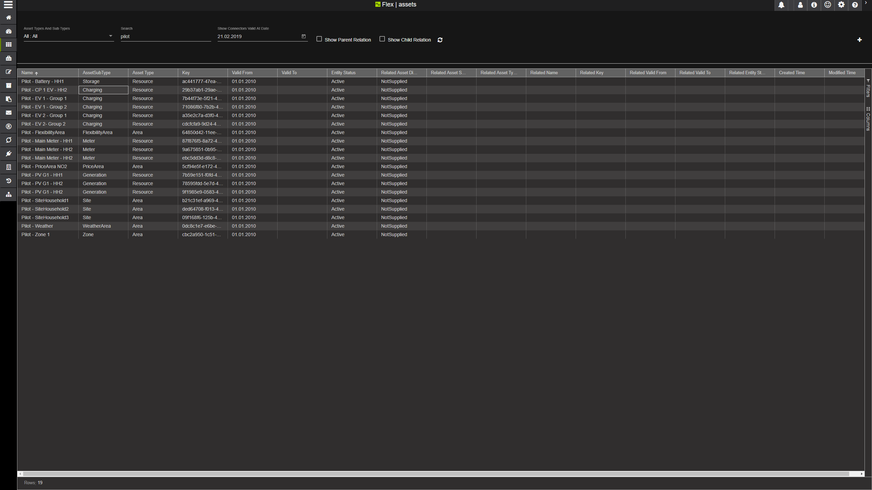
Figure 3 - Assets - search for assets, sites and areas
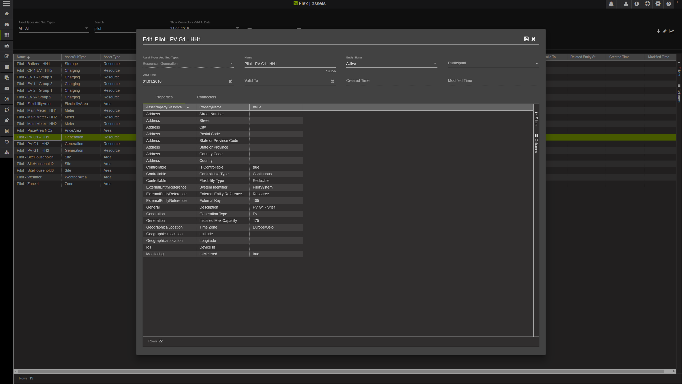
Figure 4 - Asset detail - enter or update assets and properties

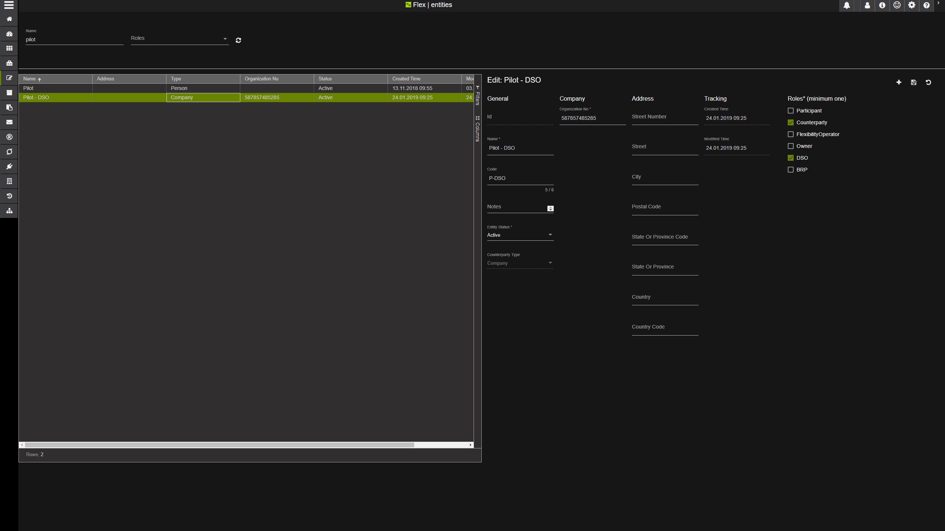
Figure 5 - Counterparty - List and details in same screen
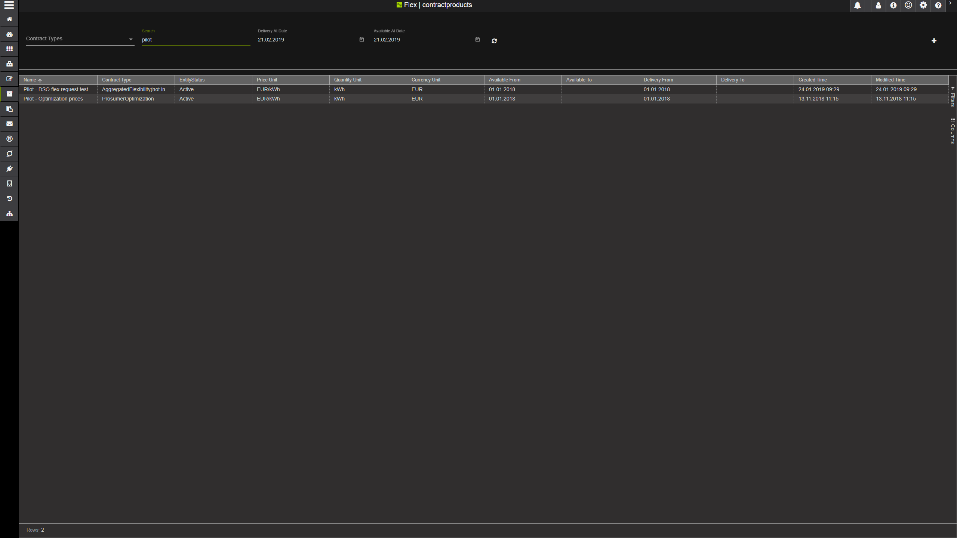
Figure 6 - Contract Product - search for contract products
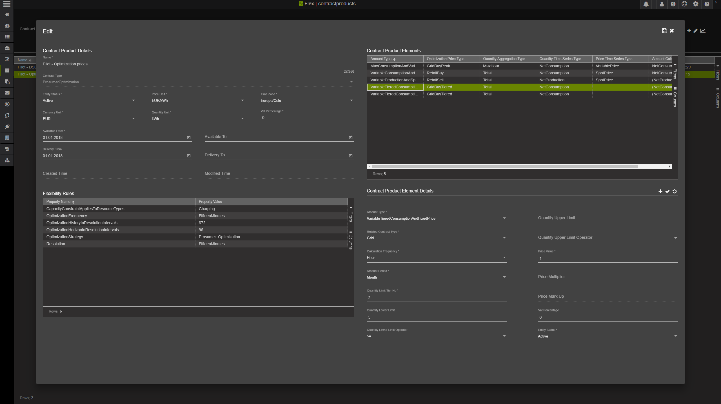
Figure 7 - Contract product details - Enter details, flexibility rules and contract product elements
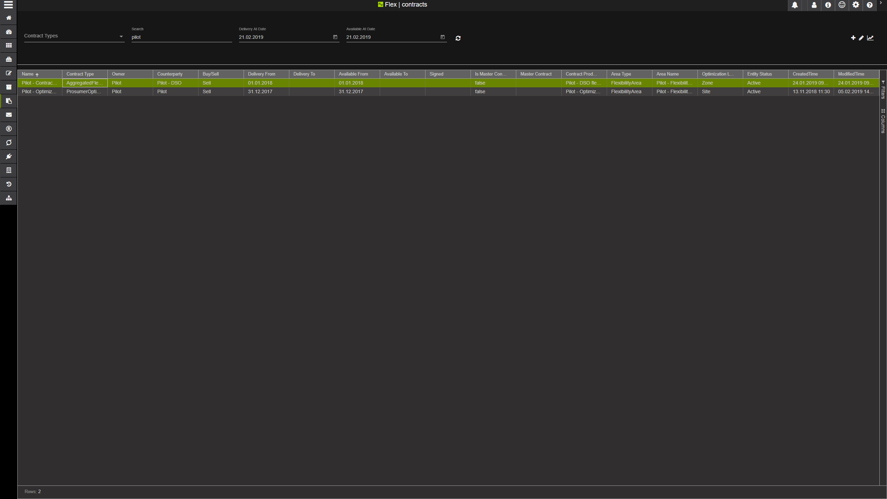
Figure 8 - Contracts - Search for contracts
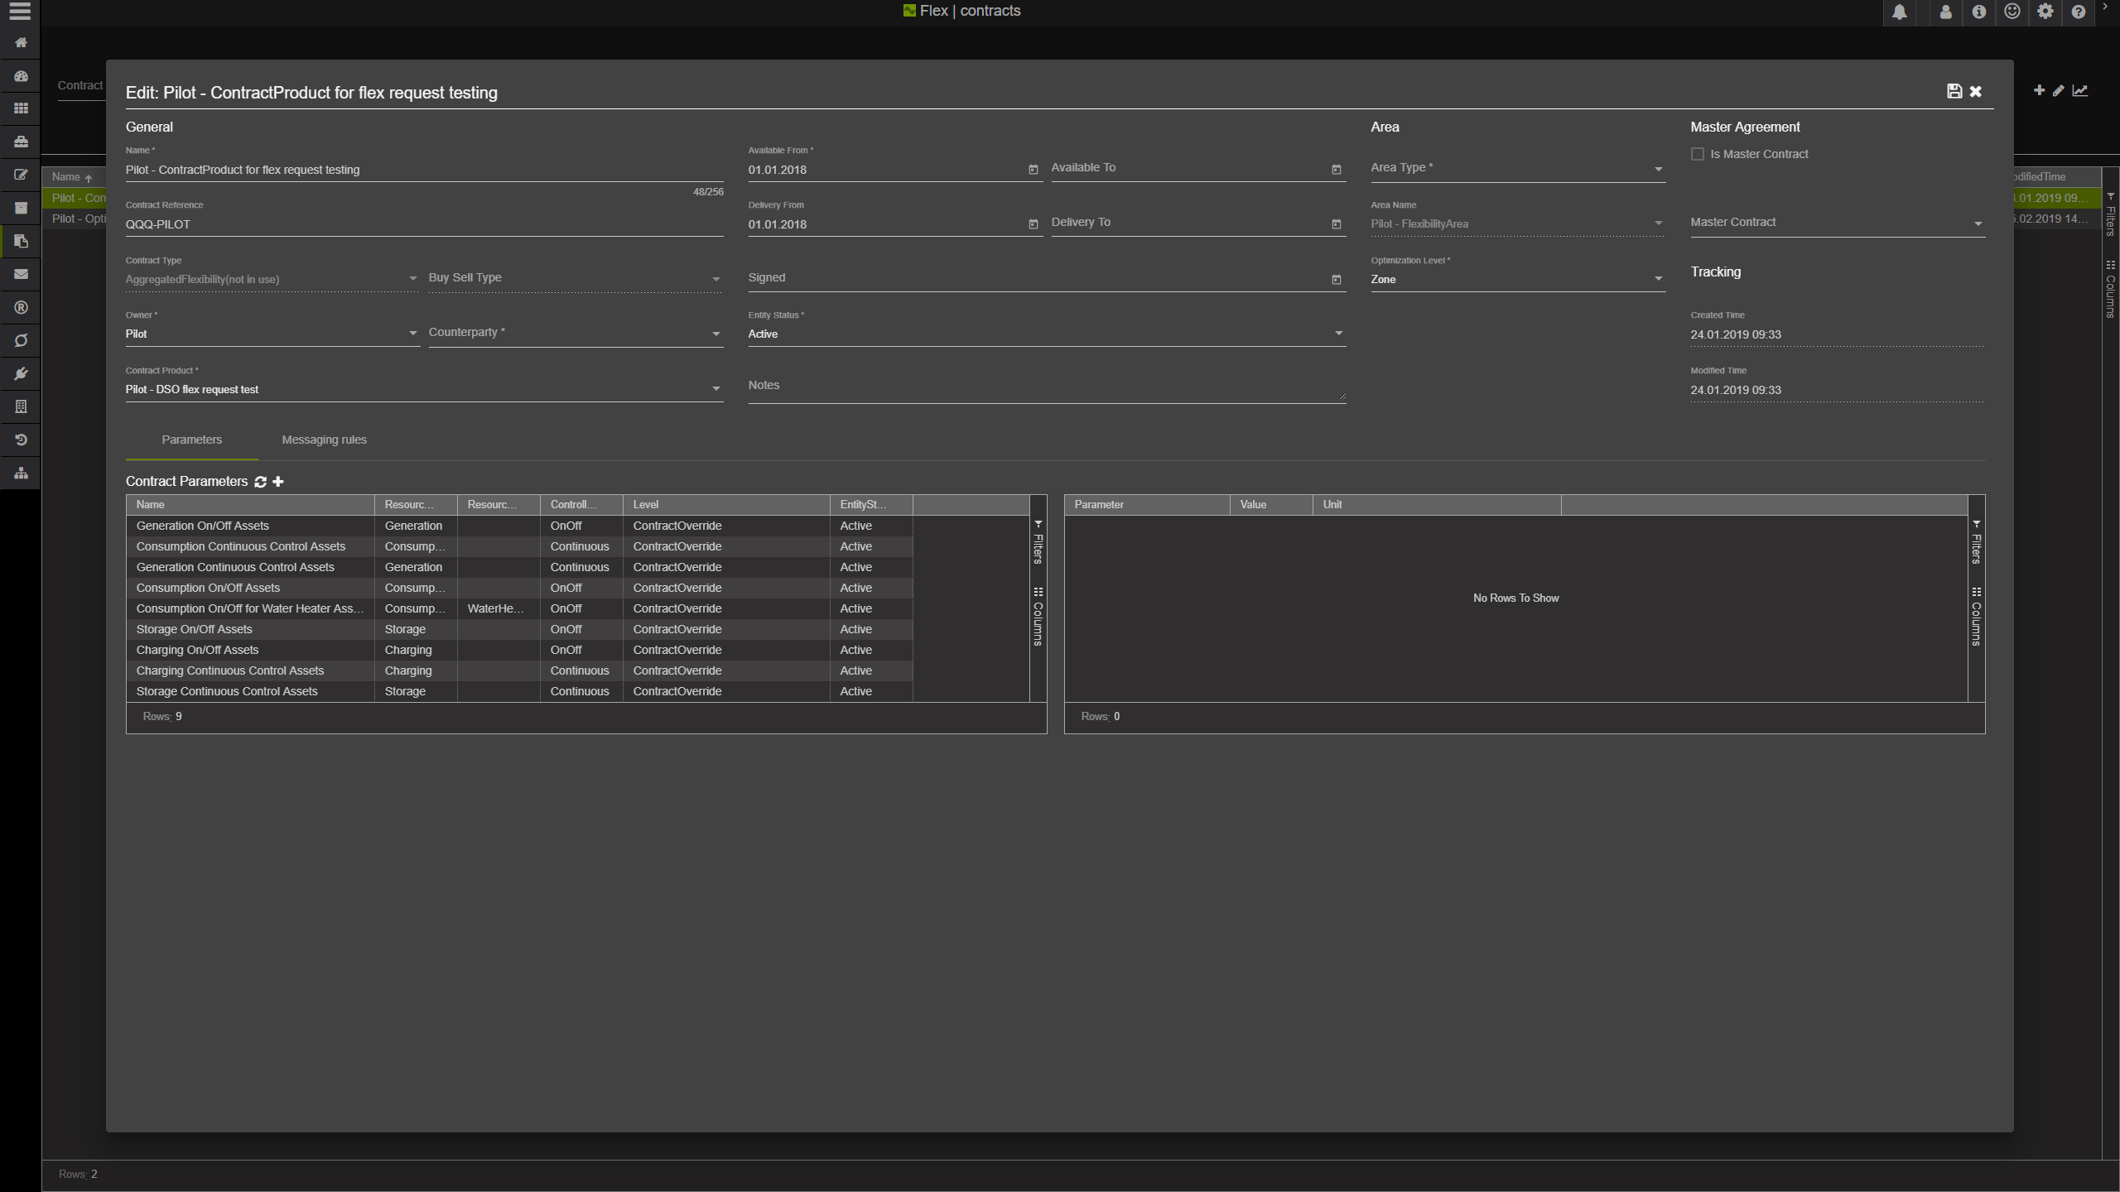
Figure 9 - Contract details and parameters
